STEWARDS POOI KEI COLLEGE

Recent
Photo
近照

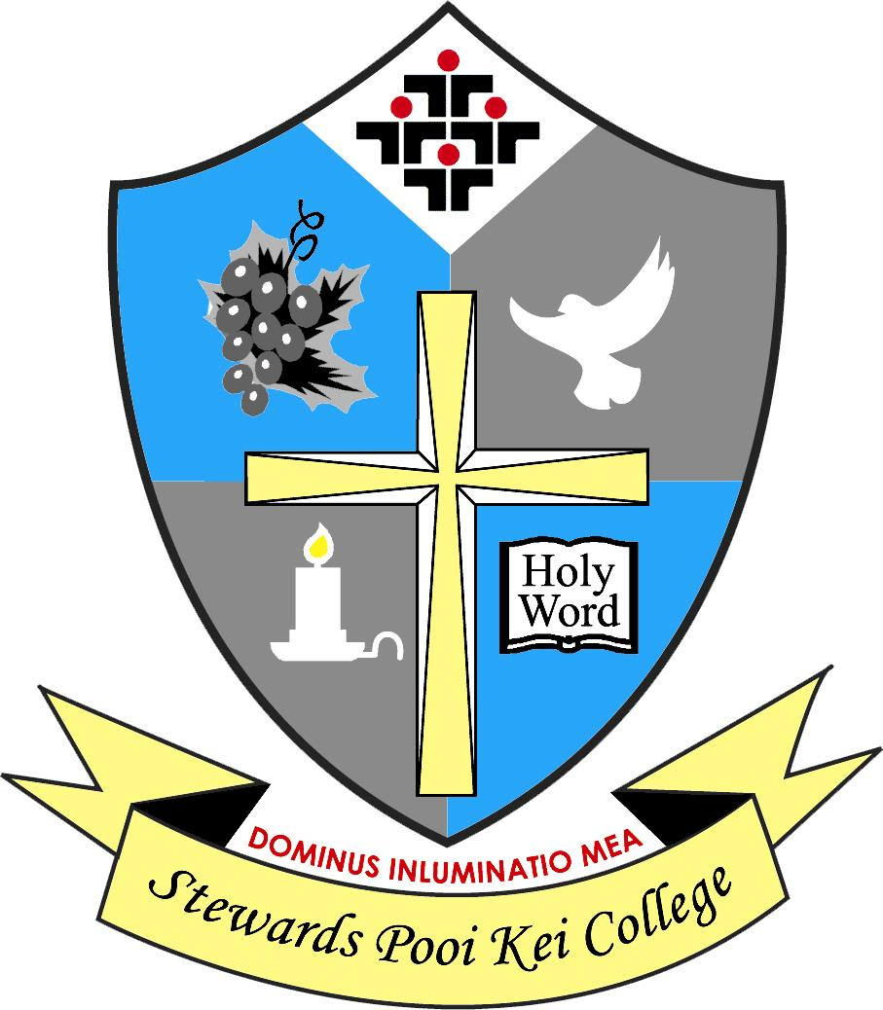
香港神託會培基書院
Secondary 1 (2023/24)
Admission Application Form (Final Batch)
二零二三/二四年度 中一學位申請表（最後階段）
(Please read the Notes for Applicants before you complete this form. 填寫此表格前，請先細閱入學申請須知。)
(For Official Use Only)  (只供校務處填寫) | Application No.  申請編號 |  |  |  |  | Submission Time  遞交時間
Name of Applicant (English)  申請人姓名 (英文) | (As shown on the HKID card) |  |  |  |  | Name of Applicant (Chinese)  申請人姓名 (中文) | (如香港身份證所示)
HKID Card / Birth Cert. No.  身份證 / 出生證明書號碼 |  |  | Sex  性別 |  |  | STRN  學生編號
Date of Birth (d/m/y)  出生日期 (日/月/年) |  |  |  |  |  | Place of Birth  出生地點
Home Address
住址
Correspondence Address  通訊地址 | (If different from the above如與上述住址不同)
Home Telephone No.  住宅電話 |  |  |  |  |  | Date of Arrival (If applicable)  到港日期 (如適用)
Previous Schools  (in Reverse  Chronological Order)  曾就讀之學校  (請倒序填寫) | Name of School 學校名稱 |  |  |  |  | Year 年份 |  | Level 班級
 |  |  |  |  |  | From To  由 至 |  | From To  由 至
 |  |  |  |  |  | From To  由 至 |  | From To  由 至
 |  |  |  |  |  | From To  由 至 |  | From To  由 至
 | Name  姓名 |  |  | Occupation  職業 |  |  | Contact No.  聯絡電話
Father
父親
Mother
母親
 | Name  姓名 |  |  | Relationship with Applicant  與申請人之關係 |  |  | Contact No.  聯絡電話
Guardian
監護人
(If applicable如適用)
Email Address
電郵地址
Relative(s)  studying in the School  在本校就讀之親屬 | Class  班別 |  |  |  |  | Relationship with Applicant  與申請人之關係
Religion  宗教信仰 |  |  |  |  |  | Church Attending  所屬教會  (If applicable如適用)

2023/24 Secondary 1 Admission Application

Notes for Applicants

二零二三/二四年度中一入學申請

入學申請須知

- Important Notes 重要事項
Please note the following when completing the S1 Admission Application Form.
填寫中一入學申請表時，請注意以下各項：
(a) Please complete the Application Form in BLOCK letters with a blue or black ball pen.
請使用藍色或黑色原子筆，並以正楷填寫申請表格。
(b) The personal data provided in the application will only be used for admission purposes.
申請中所提交之資料只供校方處理入學申請之用。
(c) If Applicant fails to provide the required information or documents, the application will not be processed.
申請人如未能提供所需之資料或文件，校方將不會處理有關申請。
(d) All submitted documents will not be returned.
所有已遞交之文件恕不退還。

2. Documents Required所需文件
□ The completed S1 Admission Application Form (Final Batch) with one recent student photo
填妥之中一入學申請表（最後階段）（貼上學生近照一張）
□ Both original and copy of the Applicant’s HKID Card or other identity documents
申請人之香港身份證或其他身份證明文件正本及副本
□ Both original and copy of the “Secondary School Places Allocation” Admission Slip
「中學學位分配」入學註冊證正本及副本
□ Both originals and copies of all School Reports from Primary 4 to 6
小學四年級、五年級及六年級各學期成績表正本及副本
□ Both originals and copies of recommendation letters, certificates of awards or extra-curricular activities (if any)
推薦信、獎狀、課外活動證書等正本及副本（如有）
□ Application fee of HK$50 in cash (ONLY for candidates selected for written test)
報名費現金港幣五十元正（獲選參加筆試者適用）

3. Application Submission 遞交申請
Please submit the required documents in person to the School during the admission period from 8:30 a.m. to 3:00 p.m. on Tuesday 11 July 2023.
請於二零二三年七月十一日（星期二）上午八時三十分至下午三時正親臨本校遞交所需文件。

4. Admission Criteria面試及甄選準則
(a) Applicants should have grade B or above in conduct in each school term from Primary 4 to 6. Students who cannot meet this requirement will not be considered.
申請人小學四年級、五年級及六年級各學期之操行必須為乙或以上，操行未能達到本校要求者將不獲考慮。
(b) Admission criteria of the School are primarily based on the applicant’s academic achievements, conduct, performance in extra-curricular activities, written test and interview performance.
入學申請按學生之學業成績、操行、課外活動、筆試和面試表現進行甄選。

5. Reservation Fee留位費
A reservation fee of cash HK$800 and a cheque of HK$1,944, which will become the school fee of the first month of 2023/24, will be collected upon your acceptance of the S1 place offered by the School right after the interview. The reservation fee is non-refundable in any circumstances.
若申請人於面試後獲本校取錄，並確認接受本校的中一學位，校方將即時收取現金港幣八百元正之留位費和港幣一千九百四十四元正的支票乙張。費用將用作二零二三/二四年度首月之學費，但在任何情況下，留位費均不會退還。

6. Fee Remission學費減免
Students from families receiving the Comprehensive Social Security Assistance (CSSA), students receiving financial assistance provided by the Working Family and Student Financial Assistance Agency (Student Finance Office) are eligible for school fee remission. Other students with financial needs may also apply. Details of SPKC Student Financial Assistance and Scholarship Scheme are available at the School website (www.spkc.edu.hk). For further information, please contact the General Office.
來自領取綜合社會保障援助（綜援）家庭的學生、領取在職家庭及學生資助事務處（學生資助處）財政資助的學生均可獲學費減免；其他有需要的學生亦可申請。有關本校獎助學金計劃的詳情，請瀏覽本校網頁(www.spkc.edu.hk)。如欲進一步查詢，請聯絡本校校務處。

Address 地址： 56 Siu Lek Yuen Road, Shatin 沙田小瀝源路56號 Tel 電話： 2345-4567 Fax 傳真： 2635-0100

